[Project Name]
Non Function Requirements

Date | [April 10, 2010]
Version | [1.0]
Status | [Approved]
Author | [Le Minh Vuong, BA]
Reviewed by | [Le Tat Hai, Project Manager]
Approved by | [Nguyen Thi Thanh Thuy, Director]

Revision History

Date | Version | Description | Author
<April 10, 2010> | <1.0> | <Define non-function requirements of TruQuote software> | <Le Minh Vuong>

Table of Contents

1 Introduction 4
1.1 Purpose 4
1.2 Scope 4
1.3 Definitions, Acronyms and Abbreviations 4
1.4 References 5
1.5 Overview 5
2 Non Function Requirements 6
2.1 Security 7
2.1.1 REQ101 - Backup Server 7
2.1.2 REQ102 - Information Security 7
2.1.3 REQ103 - Log Order 7
2.1.4 REQ104 - Synchronize Client - Server 7
2.2 Performance 8
2.2.1 REQ105 - Meet arround 100 users to access concurrently 8
2.2.2 REQ106 - System Fast Calculate 8
2.2.3 REQ107 - System must be flexible 8

Introduction

Purpose

<Define purpose of project and purpose of document>

Smart World technology is proud of being a leading IT company in Vietnam offering Smart Card and RFID (Radio Frequency Identification) technology for Education, Banking, Government and Industry.

This is document describes the Non function requirements of Stock Control.

Scope

<Provide a short description of the software being specified and its purpose, including relevant benefits, objectives, and goals. Relate the software to corporate goals or business strategies. If a separate vision and scope document is available, refer to it rather than duplicating its contents here. An SRS that specifies the next release of an evolving product should contain its own scope statement as a subset of the long-term strategic product vision.>

This is document describes the Non function requirements of Stock Control.

This document is used by development team.

Definitions, Acronyms and Abbreviations

No | Term | Description
1 | SWT | Smart World Technology Co. ltd
2 | Enduro | Client
3 | UAT | User Acceptance Test
4 | SRS | Software Requirement Specification
5 | SAD | Software Analysis & Design
6 | PM | Project Manager
7 | QC | Quality Control
8 | QA | Quality Assurance

References

<List any other documents or Web addresses to which this SRS refers. These may include user interface style guides, contracts, standards, system requirements specifications, use case documents, or a vision and scope document. Provide enough information so that the reader could access a copy of each reference, including title, author, version number, date, and source or location.>

Overview

Non Function Requirements

Audit History
Date/Time: 2010-04-15
Field:name | Formal Requirements | REQs document
 |  | 0

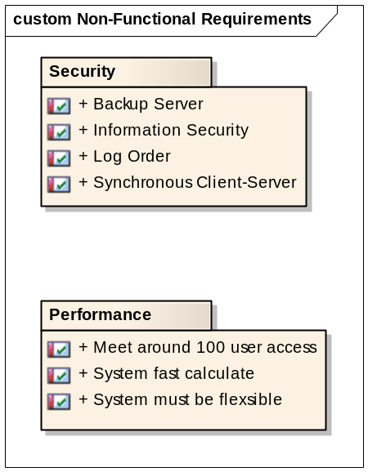

Security

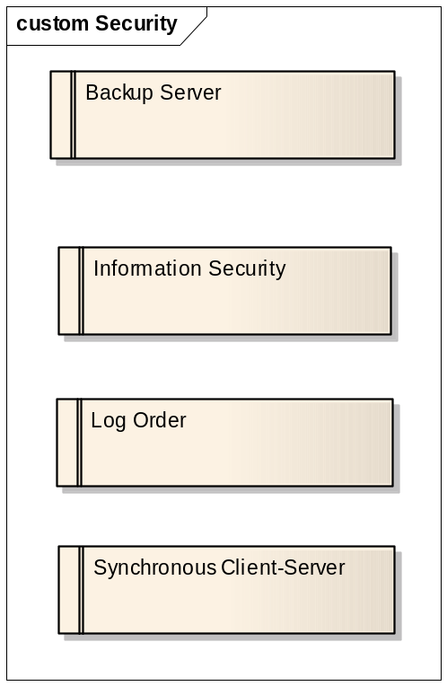

REQ101 - Backup Server
«Functional» | Status: Validated | Priority: Medium | Difficulty: Medium
«Functional» | Admin can backup all orders on server

REQ102 - Information Security
«Functional» | Status: Validated | Priority: Medium | Difficulty: Medium
«Functional» | User authentication, decentralized users.

REQ103 - Log Order
«Functional» | Status: Validated | Priority: Medium | Difficulty: Medium
«Functional» | When dealer sends order information to server time, sender will be log on server

REQ104 - Synchronize Client - Server
«Functional» | Status: Validated | Priority: Low | Difficulty: Low
«Functional» | The system must synchronize client-server data.

Performance

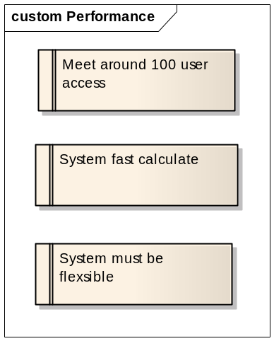

REQ105 - Meet arround 100 users to access concurrently
«Functional» | Status: Proposed | Priority: Medium |  | Difficulty: High
«Functional» | Response system for about 100 dealer accesses

REQ106 - System Fast Calculate
«Functional» | Status: Proposed | Priority: Medium | Difficulty: Medium
«Functional» | The cost of the basic specification and options are always shown below the drawings.  Performance of render 2D, 3D is fast

REQ107 - System must be flexible
«Functional» | Status: Proposed | Priority: Medium | Difficulty: Medium
«Functional» | Ability to expand new functions, add new templates, add new options

